**Sprint 1 Report**

**Actions to Stop Doing**

The team should stop holding meetings off to the side of the SCRUM board instead of in front of it, because none of the team members can read the board from where they are standing.

The SCRUM master should stop moving all tasks, because team members can do it themselves and remain engaged in doing so.

**Actions to Start Doing**

The team should ensure that all members understand all tasks and comprehend how similar tasks differ before assigning themselves to a task, since this will help reduce future confusion.

**Actions to Keep Doing**

The team should continue to actively communicate on Discord so that everyone is kept in the loop and can solve problems collaboratively.

**Work Completed**

All four user stories were completed during Sprint 1. The user stories were the following -

* As an author, I want to have my own account so that I can manage the comics I uploaded.
* As an author, I want to create comics with titles so that the reader knows what comics they are reading.
* As an author, I want to upload my comic pages so that other users can view them.
* As a reader, I want to have page navigation so that I can easily return to the page that I left off on.

Thus, nothing was left incomplete

**Burn Up Chart**

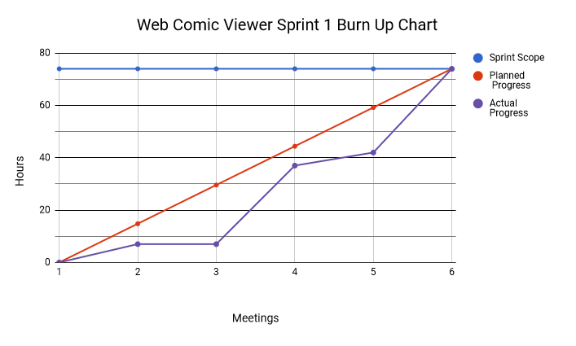.

**Work Completion Rate**

As stated in the prior section, all four user stories were successfully completed over the course of Sprint 1. This nets a total of 74 ideal work hours. The sprint spanned over 12 days, 10 of which were weekdays. Because we completed all user stories, the ideal hours/day is 5 and the user stories/day is 0.33.